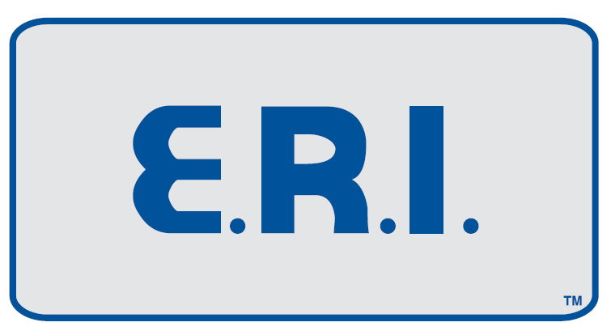
2025 Annual General Meeting
Calgary, Alberta
Saturday, October 25th, 2025
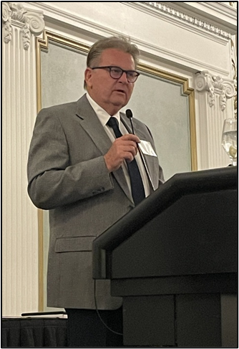
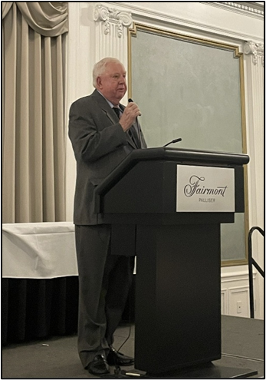
Calgary, Alberta
The E.R.I. Group held their 2025 Annual General Meeting and Directors Meeting at the historic and beautiful Fairmont Palliser Hotel in downtown Calgary, Alberta. The Saturday business meetings were once again followed by an evening cocktail reception and dinner social function attended by E.R.I. Group members, alumni, and staff to include their spouses. Also attending by special invite, was Melling Engine Parts. Following dinner, the E.R.I. Group Chairman of the Board, Rick Miller and E.R.I. President Bill Hay, presented various awards to attending members
Pictured Above: The E.R.I. Group President, Bill Hay.
Pictured Above: The E.R.I. Group Chairman, Rick Miller.
and staff to include Melling Engine Parts!
____________________________________________________
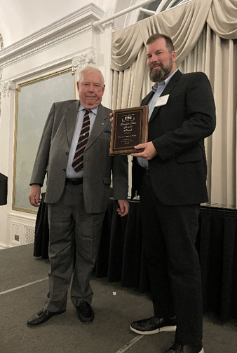
Chairman Rick Miller presented the
“2024 Largest Sales Growth Award”
to Melling Engine Parts.
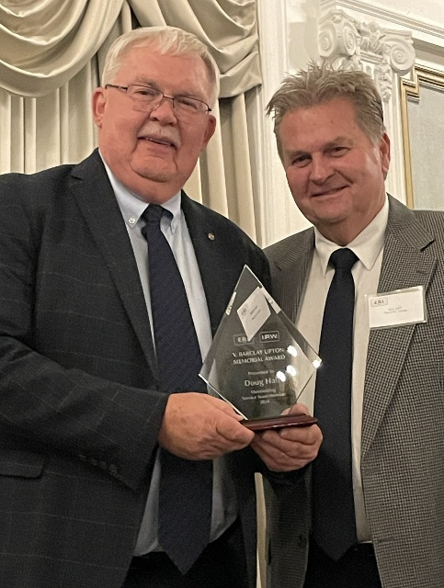
Accepting the award was
Melling’s Eastern Regional Sales Manager,
Mr. Doug Smith.
Pictured to the left.
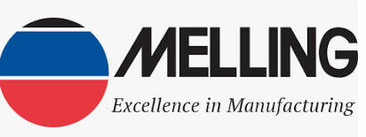
___________________________
The V. Barclay Upton Memorial Award is presented annually to the highest performing E.R.I. Service Team Member. This year the 2024 award was presented by E.R.I.’s President Bill Hay to Service Team Member, Mr. Doug Hall.
Pictured on the right.
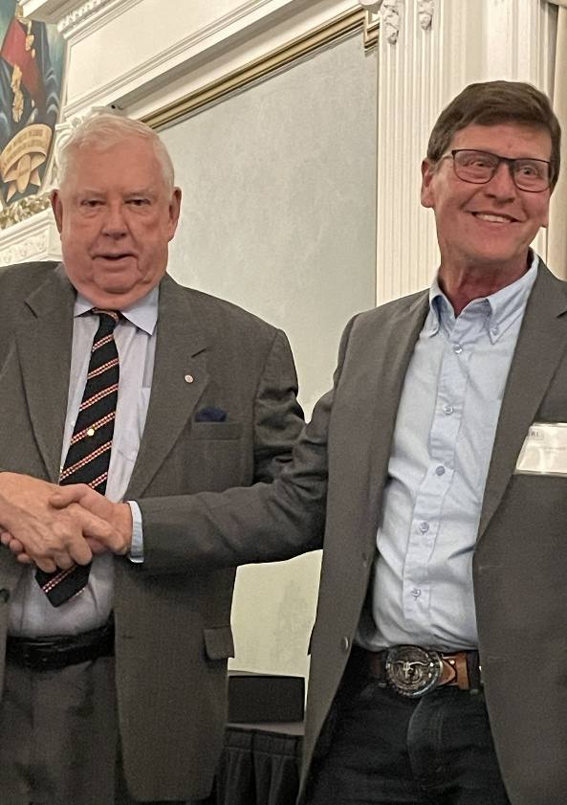
The E.R.I. 2024 Order Desk Person of the Year Award, which is determined by the members, went to our I.P.W. Edmonton Warehouse Manager Mr. Rob Wagner. The award was presented to Rob by Chairman Miller.
Pictured on the left.

___________________________________

Chairman Miller presented the Sales Rep of the Year Central
Canada for 2024 to Service Team Member Mr. Doug Hall.
This was Doug’s second award of the night!
Pictured on Bottom Left.
Chairman Miller then presented The E.R.I. Tenure Award Pin, recognizing Staff and Member’s significant milestones with the organization! E.R.I. is most fortunate to have dedicated staff and great members as part of the group!
I.P.W. Edmonton Branch Manager Rob Wagner being recognized for 5 years service! Pictured on Bottom Right.

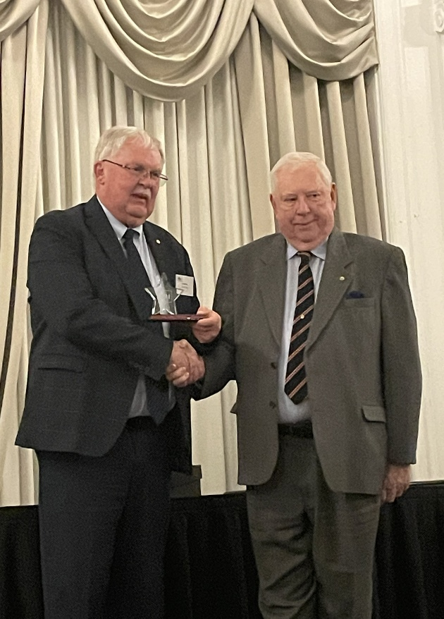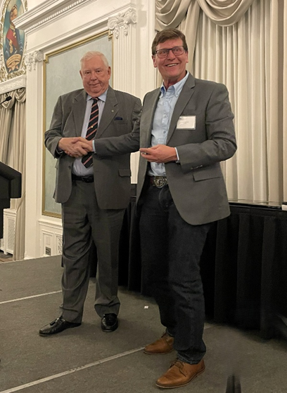
Pictured Above: Rick Miller and Mr. Doug Hall Pictured Above: Rick Miller and Mr. Rob Wagner
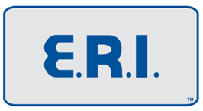
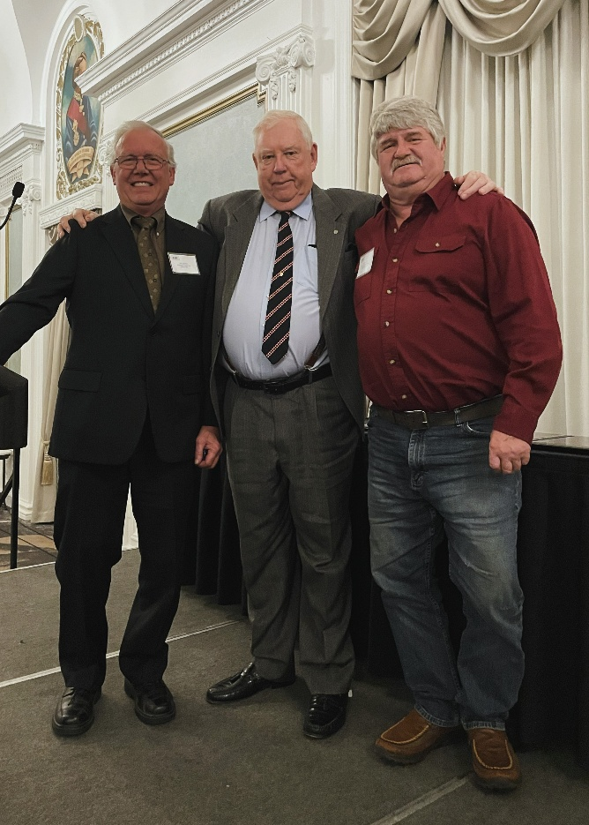
The E.R.I. Group recognized F.A.K. Automotive’s owner &
operator Fred Klotz (Drayton Valley, Alberta) and Northeast
Engine Ltd.’s owner & operator, Jim Zimmer (Melfort,
Saskatchewan) for their 20 years of membership with E.R.I.
Pictured to the Right.

Unfortunately, absent- Frank Fortin, owner of Alberta
Cylinder Head and Engine Rebuilders (Edmonton, Alberta)
could not attend to celebrate their 5 years of recognition
with E.R.I.

At this point in the evening, Chairman Miller
presented plaques to the attending Quarter Million Club Members who have reached or exceeded $250,000 in E.R.I. purchases during the 2024 calendar year.
Pictured Below.

Almax Engine Rebuilders Ltd. (Red Deer, Alberta) Northeast Engine Ltd. (Melfort, Saskatchewan)
Owner & Operator Logan Vass Owner & Operator Jim Zimmer
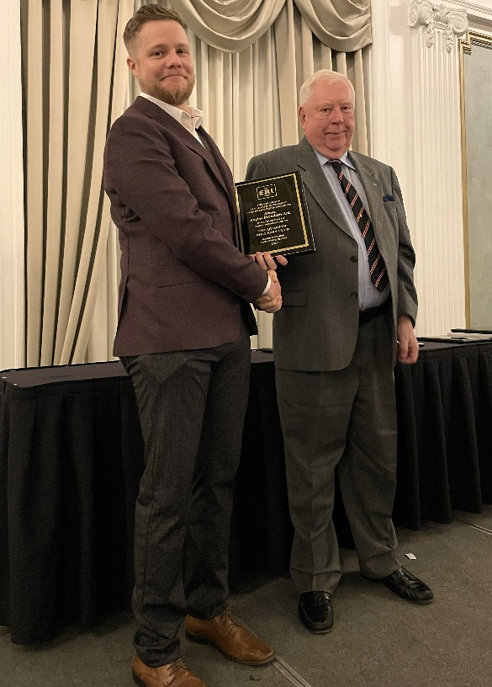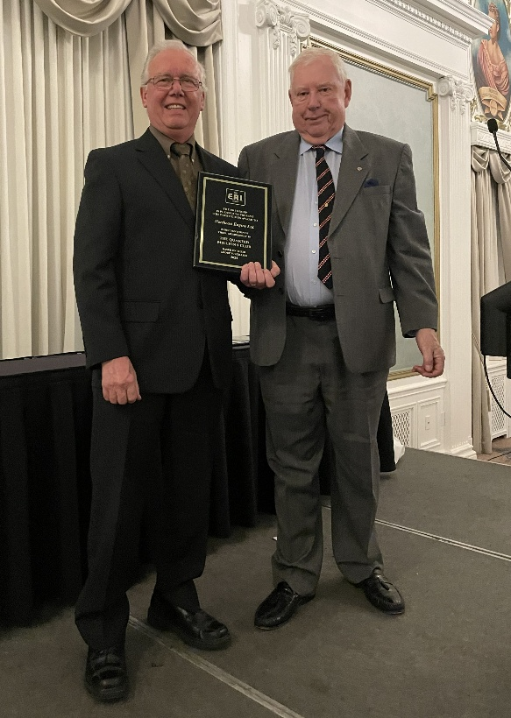
Pictured Above: Rick Miller & Logan Vass Pictured Above: Rick Miller & Jim Zimmer
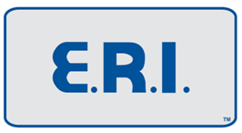
Powerhouse Machining Ltd. (Edmonton, Alberta) Total Engine Services Ltd. (Peace River, Alberta)
Owner & Operator Ryan Brewster Owner & Operator Larry Doll
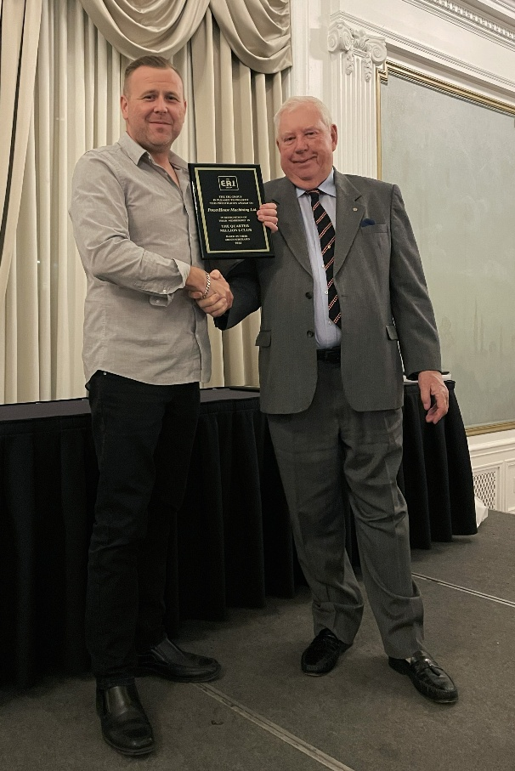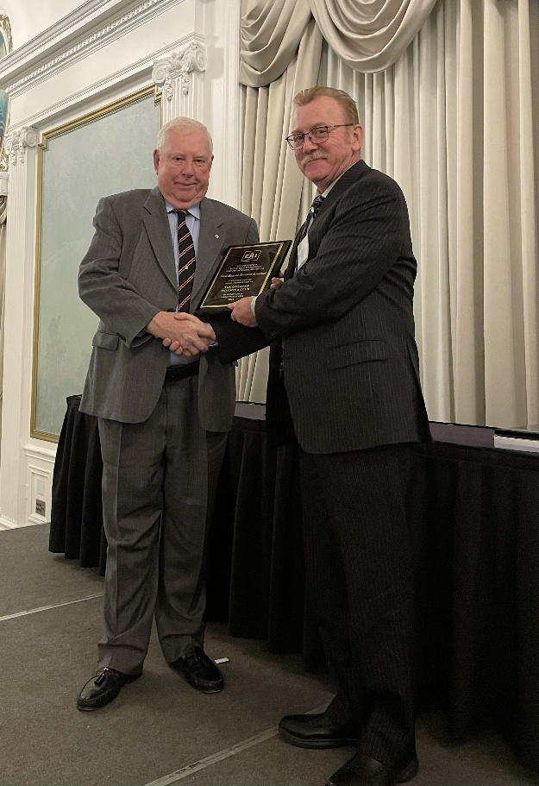
Pictured Above: Rick Miller & Ryan Brewster Pictured Above: Rick Miller & Larry Doll

Powerhouse Precision Engines Inc. (Saanichton, British Columbia)
Owner & Operator Evan Jennings
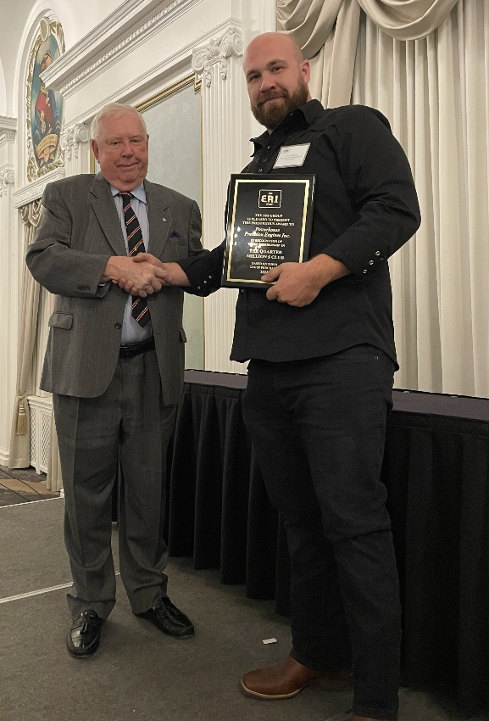
Pictured Above: Rick Miller & Evan Jennings
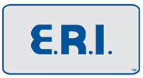

Finalizing the award ceremony portion of the evening, Chairman Miller presented a plaque to
attending Guild Club members who have reached or exceeded $500,000 in E.R.I. purchases during the 2024 calendar year.

Beatty & Woods Ltd. (Mississauga, Ontario)
Owner & Operator Charles Beatty
Pictured Below: Rick Miller and Charles Beatty
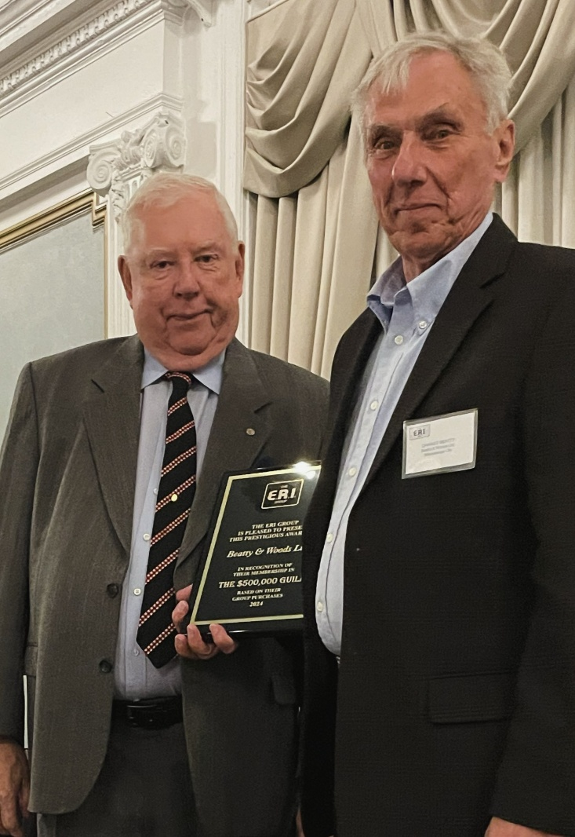
Chairman Miller noted that there were two other members receiving Guild Club Award status this evening, unfortunately they could not be with us tonight.
Those members are; Nova Automotive of Dartmouth, Nova Scotia, owner & operator Rick Hamilton. First time Guild Club winner, Alberta Cylinder Head and Engine Rebuilders of Edmonton, Alberta, owner & operator, Frank Fortin.
Chairman Miller also recognized Guild Club Member, Marc Arsenault, owner & operator of Arsenault Cylinder Heads Ltd., of Scoudouc, New Brunswick who was in attendance tonight! Marc was presented with his Guild Club Plaque at the E.R.I. Spring Meeting in Charlottetown, Prince Edward Island.
As tradition would have it, the complimentary evening featured a fabulous five-course dinner at the Fairmont Palliser Hotel! All in attendance enjoyed making new acquaintances and certainly enjoyed renewing old acquaintances. As we always mention, if you have never attended one of our Spring or Fall meetings hosted near you, we encourage you to attend next time around. As always, the venue provides terrific opportunities to meet, chat and connect with fellow members, including E.R.I. and I.P.W. staff. (additional pictures below from our enjoyable evening).

